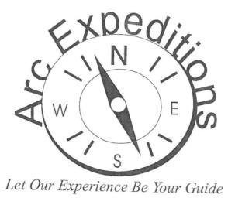
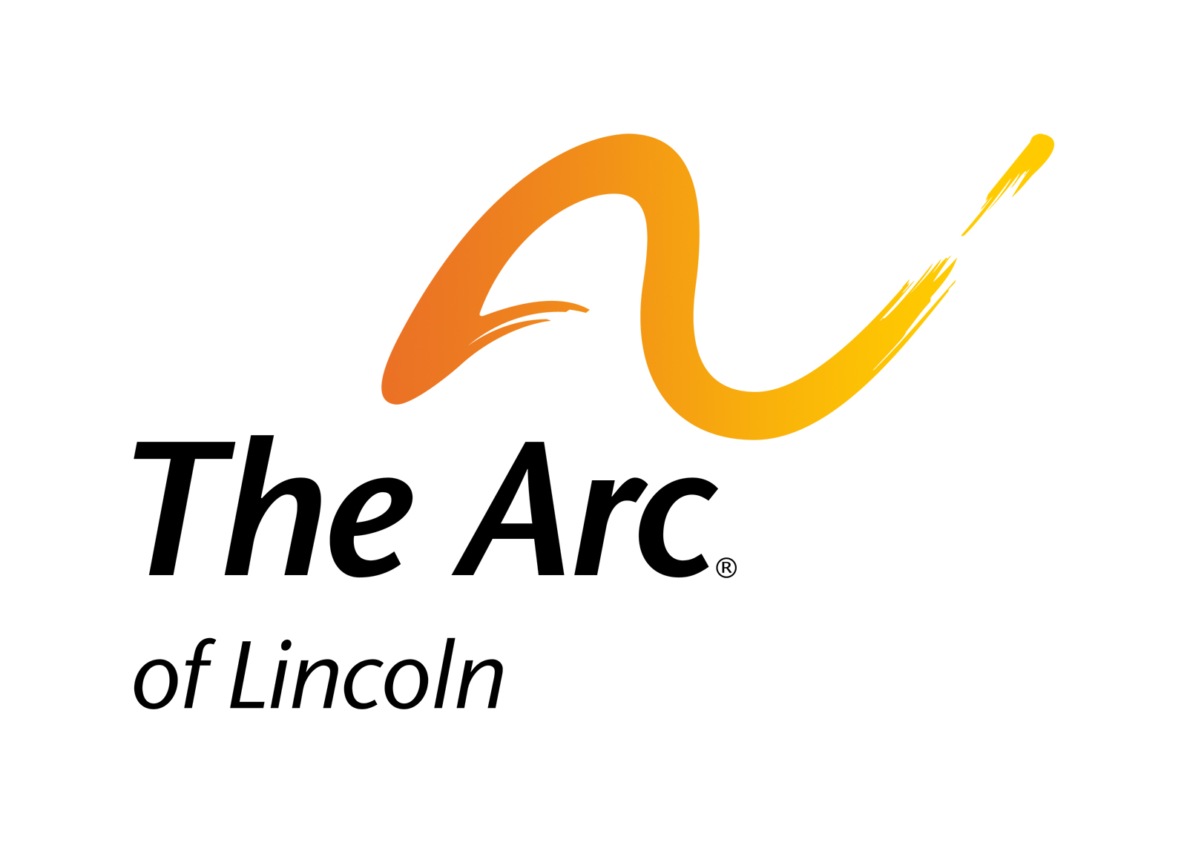
2022 VACATIONER APPLICATION
The Arc of Lincoln 6500 Holdrege, Lincoln, NE 68505
402.421.8866 |director@arclincoln.org | www.arclincoln.org

Vacationer’s Legal Name Gender (M/F)
Street Address City/State/Zip
Preferred Name (and/or common nicknames) Birthdate
Please check the box of the trip(s) you would like to register for:
 Ladies Night Out in Kansas City May 13-15
Girls only, Walking, Van Trip $850
 Men’s Weekend in Kansas City June 24-26
Men only, Walking, Van Trip $800  Mall of America in Minnesota July 12-17
Everyone, Walking, Van Trip $1960
 Husker Football Game TBA $275

 Salt Dogs Baseball Game TBA $150
 Iowa Fair August 11-14
Everyone, Walking, Amusement Park, Van Trip $800
 Worlds of Fun Spooky Nights October 29-30
Everyone,Walking, Amusement Park, Van Trip $525
 Branson Missouri November 16-21
Everyone, Walking, Van Trip $1250

Primary Contact and Phone Number:
Email for correspondence/paperwork:
Relationship to Vacationer?  Parent  Guardian  Direct Care Staff  Other
Agency Name (if applicable)
Street Address City/State/Zip
Phone – Cell: Day: Night:
Mail trip information to:  Applicant  Primary Contact  Other
Mail billing information to:  Applicant  Person Completing Application  Other
Payment/Deposit: All trips require a deposit. The deposit for van trips is $100. See the 2022 trips booklet for Registration and Deposit deadlines for each trip. Make a check payable to “The Arc of Lincoln.” Mail this form and the deposit check to address PO Box 57002, Lincoln, NE 68505.

