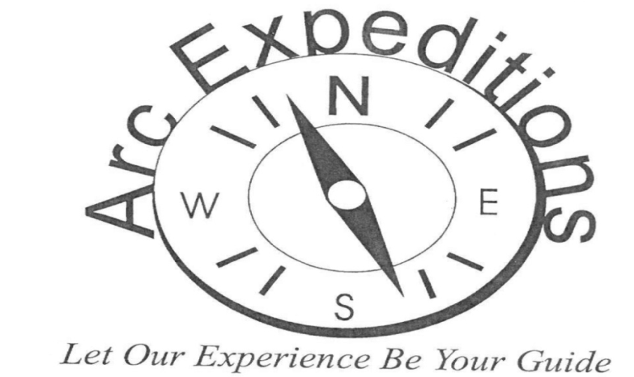
2021 Arc Expedition Trips
Zoo Weekend in Kansas City Missouri and Topeka Kansas June 4th thru June 6th $600.00 deadline to sign up April 1st
The group will be spending the night in KC on Friday night and going to the KC zoo on Saturday, then driving to Topeka KS on Saturday night and visiting the Topeka zoo on Sunday and returning home on Sunday evening. This will be a driving trip and will require moderate walking at the zoos.
Ladies Weekend in Kansas City June 25th thru June 27th $650.00 deadline to sign up April 1st
A much-needed weekend after 2020 of pampering to include; lots of laughs, friendships, good food, entertainment, manicure and pedicures and everyone’s favorite shopping. This will be a driving trip.
Wisconsin Dells July 15th thru July 19th $1500.00 deadline to sign up May 1st
What personality are you? A thrill seeker, a nature lover, history buff, laid back or animal lover? The Dells has a little bit of everything to fit everyone’s needs. Activities to include Dells boat tour, Timbavati Wildlife Park, scenic river walk, water parks, circus world, and of course shopping. There are some beautiful horseback trails for those who might be interested. This will be a driving trip.
Cheyenne Frontier Days, Wyoming July 29th thru August 2nd $1600.00 deadline to sign up May 1st
The first Frontier Days were held in 1897 for one day and now it has become a 10-day world famous western celebration. Activities to include parades, carnival rides, games, museums, concerts, Chuck Wagon breakfasts, Cheyenne Gun Slingers, and of course shopping. There is a little something available for everyone. Michelle’s favorite singer Blake Shelton will be making an appearance at Cheyenne Frontier Days. This will be a driving trip and will require moderate walking.
Husker Football Home Game TBA $275.00 deadline to sign up May 1st
So 2020 was a year of many disappointments, but we hope with the New Year we will be able to enjoy some Husker Football and cheer on the Huskers down in the handicap section of the N Zone. The group will be tailgating before the game. Michelle will be talking with the ticket office to be able to purchase tickets. A date will be announced as soon as we can.
Salt Dogs Wednesday night at the park TBA $150.00 deadline to sign up May 1st
Baseball lovers, this is the day trip for you! Come enjoy Lincoln’s own baseball team. The Salt Dogs Stadium has been named #1 Stadium for the past 15 years. We will be enjoying ballpark food from the comfort of our very own suite! The game will be on a Wednesday evening in August and Michelle will announce the date as soon as schedule is posted. Sign up for this trip to enjoy spending time with friends at the ball park watching America’s favorite past time.
Men’s Weekend in Des Moines Iowa August 27th thru August 29th $650.00 deadline to sign up May 15th
Des Moines is the capital city of Iowa, and will be this year’s destination for the annual men’s weekend. Pack your bags and be ready for a weekend of no cleaning rooms, making beds, or cooking. Activities will include arcade games, pinball, horse racing, slot machines, dinner on a train and male bonding. There is an activity for everyone! This is a driving trip.
South Dakota Adventure September 9th thru September 13th $1400.00 deadline to sign up June 1st
It’s time once again to visit the beautiful Badlands of South Dakota and all of its beauty and history it has to offer our group. Activities to include; Mount Rushmore, Crazy Horse Memorial, Spearfish Canyon scenic byway, 1880 train. We will be stopping at the famous Wall Drug for free ice water and shopping. This will be a driving trip with moderate walking during activities.
Train to Chicago Illinois September 23rd thru September 27th $1550.00 deadline to sign up June 1st
The Amtrak train will be leaving Lincoln and we will be heading to the windy city of Chicago for some yummy Chicago food of deep-dish pizza, Chicago dogs, and make sure you bring your walking shoes as we will be touring Navy Pier, Shedd Aquarium and becoming familiar with the L Train. The group will be staying at a vacation home for this trip. This trip will be on the Amtrak train and the group will be utilizing public transportation during the trip of the city buses and L subway system.
Halloween at Worlds of Fun October 16th thru October 17th $450.00 deadline to sign up June 30th
Worlds of Fun is decorated for the Halloween holiday, so keep your eyes open for those twists and turn throughout the park. We will be spending all day and evening at the park on Saturday. Sunday we will be eating lunch and enjoying bowling, arcade games, laser tag, and rope climbing at Main Event, before returning home.

Branson at Christmas time November 18th thru November 22nd $1250.00 deadline to sign up August 1st
One thing I missed most about 2020 was not visiting Branson for Christmas for the annual Arc Expedition trip. This year we will be entertained by numerous new shows, and yes, I promise an Elvis sighting, as I know this is one of the favorites. Our trip will begin with a delicious dinner at the world-famous home of the thrown rolls Lamberts Café. The week will be packed with exciting performances, delicious food, and beautiful Christmas lights. There will be time to shop and give Santa your Christmas list. This is a driving trip.

